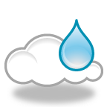
Water Cycle O-W-L Chart
O  Observations | W  Wonderings | L  Learnings

